REPORT

# KITCHEN STORY

By,

### Devnath Tandi

(devnath.g22@gmail.com)

OVERVIEW

The project ‘THE TASTY KITCHEN’ is a restaurant website made using HTML and CSS for customers to get to know about the restaurant.

## GOALS

* Landing page for the restaurant.
* To provide the information about the restaurant.
* To provide the recipe menu list and services provided by the restaurant.
* Directing the website visitors to order the food in a food ordering website like zomato.
* Making the website visitors to follow the social media page of the restaurant.

## SPECIFICATIONS

* We added a logo and navigation bar items for easy use of the website.
* Added the picture with details of the recipes and the information services provided by the restaurant.
* People can use Contact Us form to give feedback or for any queries.

## TOOLS

★ HTML

★ CSS

★ VS code

★ Google Fonts

## FILE STRUCTURE

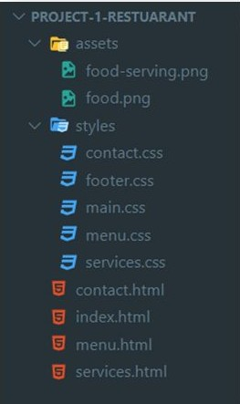

## OUTPUT

Note: Recommended the desktop view is best, not responsive to mobile screen.

### HOME

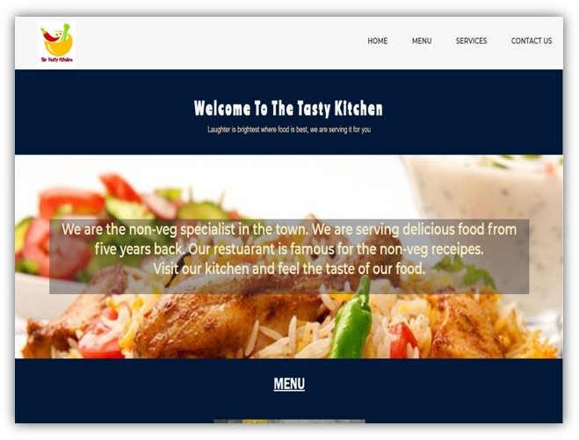

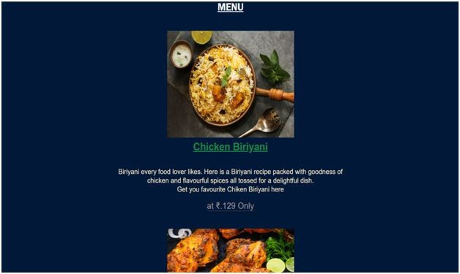

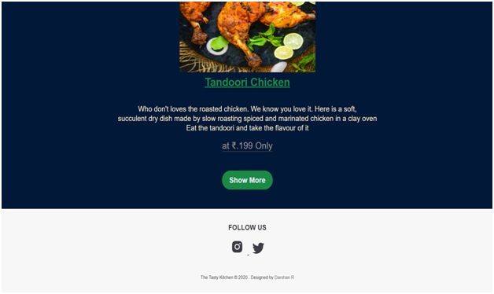

MENU

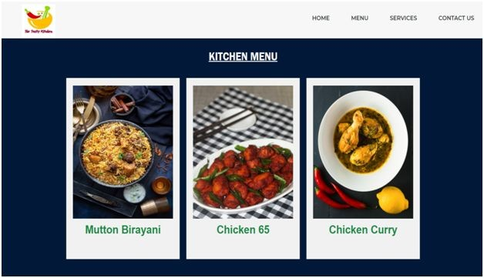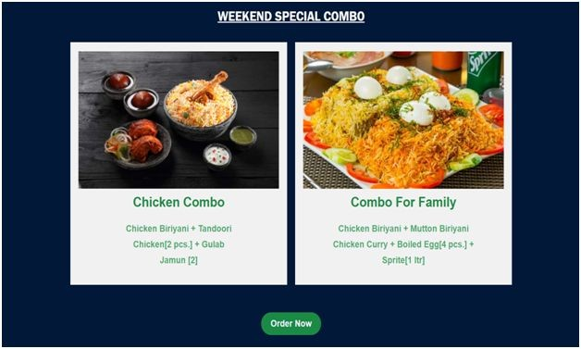

### SERVICES

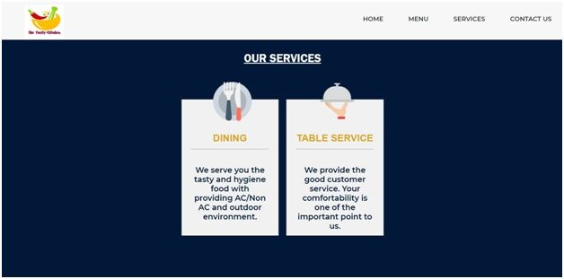

CONTACT US

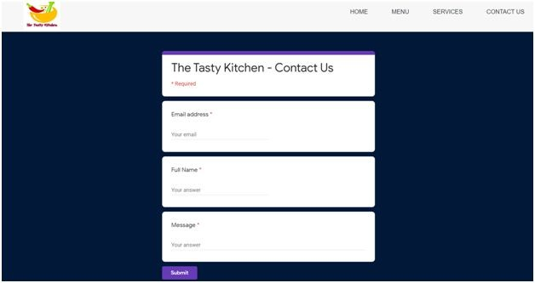

# THE END THANK YOU